07/01/21
Dear Y5 Parent/Guardian,
Unfortunately, we find ourselves in this position where the school closed and pupil learning is expected to take place at home. I shall post a daily update on the Y5 class page of the school website and further details about your child’s learning shall be on the Purple Mash platform. It is accessible on just about any device including mobile phone.
During this period of school closure, we shall use this resource, in addition to the paper based materials that were sent home last term. Teaching shall be directed via the Year 5 class blog. Your child should check it on a daily basis for updates and instructions regarding learning.
Your child will already be familiar with this website from earlier in the year but if you experience any technical problems accessing it, please email the school and I shall endeavour to resolve any problems as soon as possible.
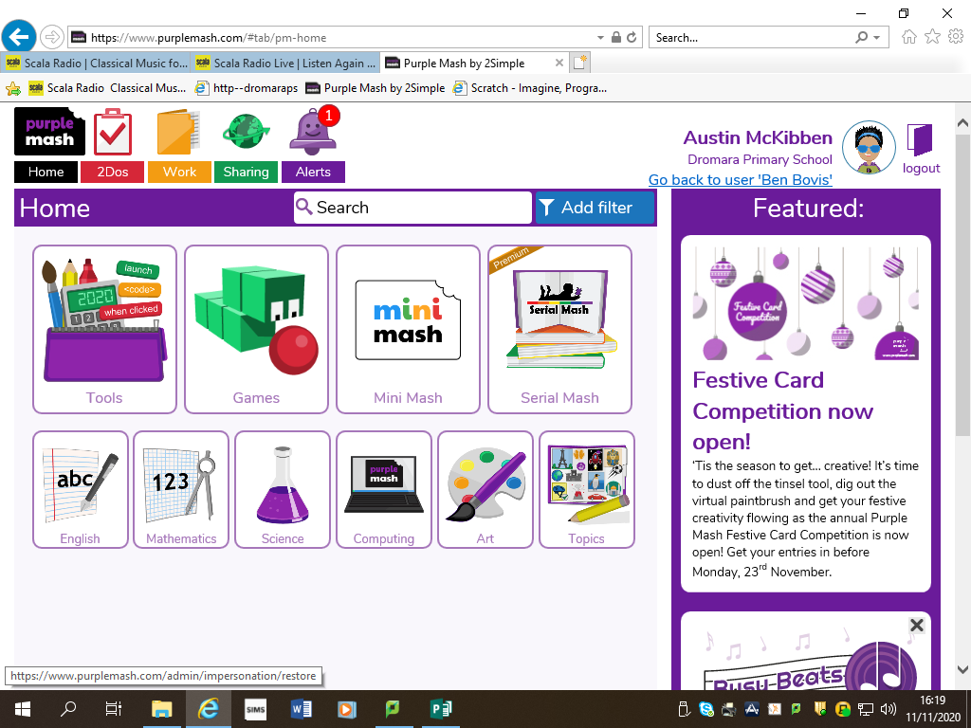

Instructions for accessing the blog are overleaf.

1. Your child should sign in on Purplemash.com, remembering to choose the school portal first.

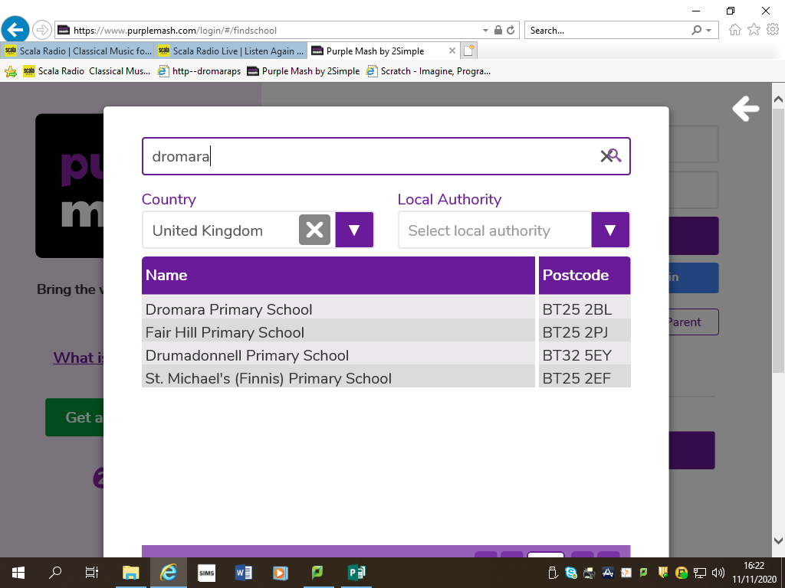

2. When logged in, click on the ‘Sharing’ icon along the top.
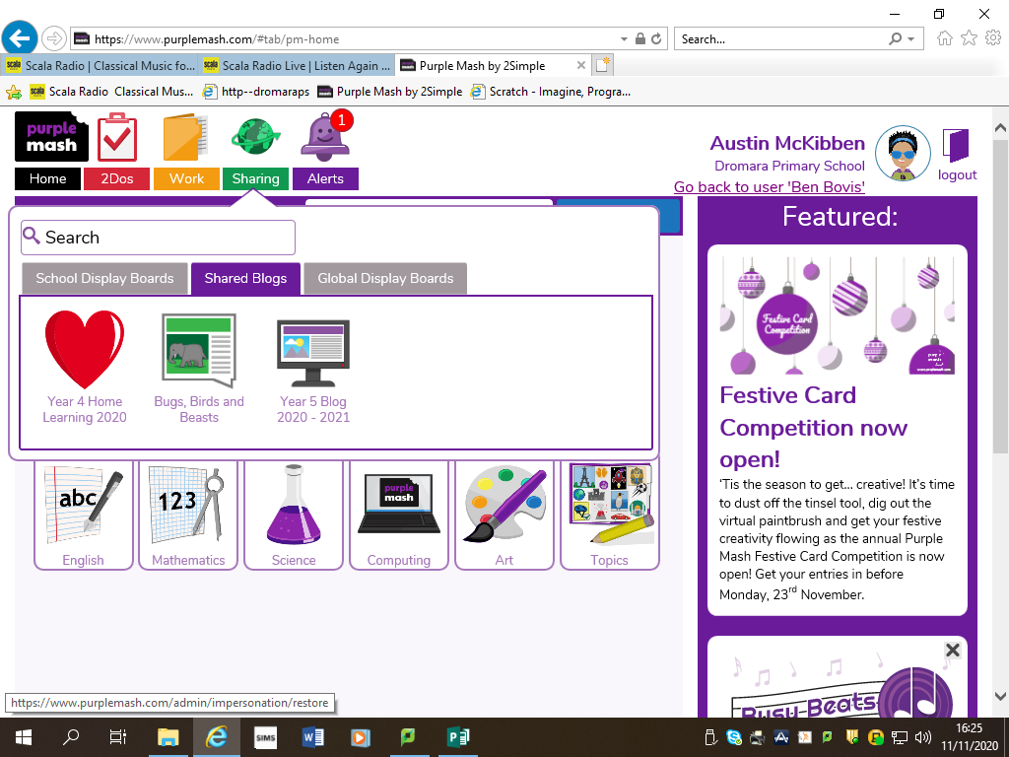

3. Click ‘Shared Blogs’, followed by the ‘Year 5 Blog 2020-2021 link.
Please encourage your child to look for ‘alerts’ that I have posted - there should be a red circle above the purple bell on the home page.

